Automating medical diagnosis to reduce human error and speed up treatment has been a goal of many medical professionals for decades. In 1989, a researcher published a study using logistic regression to predict whether patients with who had been referred for angiograms were suffering from coronary artery disease. That research made use of all the information expected to be clinically relevant from a standard battery of tests. It is conceivable, however, that some of this data may have been less relevant than assumed, which would make some of the tests unnecessary, and could actually have reduced the discriminant function’s accuracy.

Goals and Research questions:
Is it possible to reduce the number of tests necessary to screen for a disease in a clinical setting without impacting diagnostic accuracy? By quantitative analysis of the results of standard test results, we hope to identify which are actually critical to effective diagnosis, and which are unnecessary.

Hypothesis:
The key testable hypothesis of this study is that a model based on carefully selected subset of test results can match or exceed the accuracy of a model built using all the available clinical information.

Data source:
The data source for the analysis are the clinical and noninvasive test results for a group of patients undergoing angiography at the Cleveland Clinic in Cleveland, Ohio. The dataset was first published in the American Journal of Cardiology in 1989, and an anonymized subset (14 of the 76 original variables) was made publicly available on the UCI Machine Learning Repository and the Kaggle dataset repository by David Aha. This subset corresponds to the 13 predictor variables used in the initial study, and a 14th representing whether the patient’s angiogram showed substantial (over 50%) narrowing.

Data management
Features from the dataset were selected for the model based on modified Kolmogorov-Smirnov goodness-of-fit tests to compare the distribution of each variable among patients with heart disease with that of patients without. This test both determines whether the two distributions are significantly different, and also provides a measure of the degree of difference in the form of the KS statistic. A level of 20% (or 0.2) was selected as the minimum for a variable to be included in the model.

Modelling
The training data was used to fit a generalized linear model (GLM) with logit (logistic regression) classifier to the selected and normalized variables. While there are a number of alternative methods to develop classifiers, a logit was used in 1989 when the dataset was assembled, which makes it the best way to compare the impact of our feature selection and transformation on prediction accuracy.
We also trained a support vector machine (SVM) using the same training data. This is are commonly-used machine-learning algorithms that can perform the same sort of classification task as the logistic regression, but may provide a higher or lower level of accuracy depending on the task and dataset.
Figure 4: Confusion matrix for GLM Figure 5: Confusion matrix for SVM
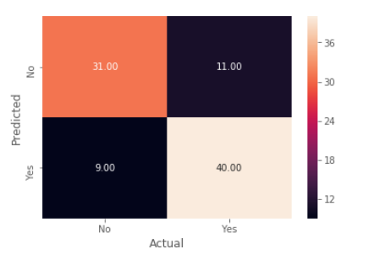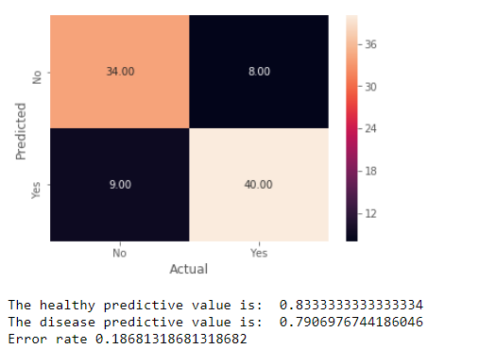
Figure 4: ROC curve for GLM Figure 5: ROC curve for SVM
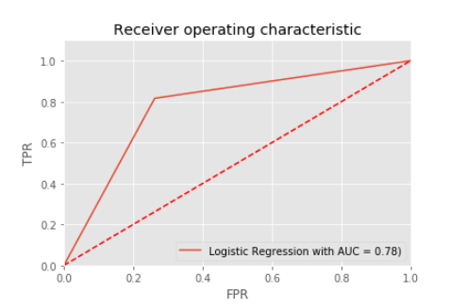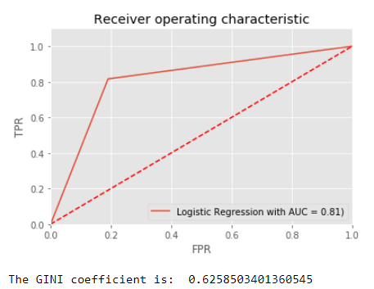
The area under the curve (AUC) of the GLM model was 0.78. The AUC represents the approximate accuracy: a score of 1 would mean perfectly accurate, while a score of 0.5 would mean it was only accurate half the time, equivalent to randomly guessing yes or no. This means that our classifier was quite successful at predicting whether a given patient had heart disease or not. The area under the curve for the SVM was somewhat better, at 0.81

Conclusions
The estimated predictive accuracy of our support vector machine classifier is 81%, which is a modest improvement on the predictive power of the discriminant function developed in the original 1989 paper using all 13 ‘clinically significant’ variables. Our classifier was built using only a subset of those variables, selected based on the difference in their distributions (K-S statistic) between patients with and without coronary disease.

Detrano, R., 1989, “International application of a new probability algorithm for the diagnosis of coronary artery disease.” American Journal of Cardiology 64.
Ibid.
https://archive.ics.uci.edu/ml/datasets/Heart+Disease
https://www.kaggle.com/ronitf/heart-disease-uci

